

YEAR: 7
2019
SUBJECT: Science

TEST: Classification
TIME: 50 minutes
QUESTIONS: 10 Multiple Choice (10 marks)
8 Short Answer (31 marks)
TOTAL MARKS: 41 marks

DO NOT WRITE ON OR MARK THIS PAPER

Part A: Multiple Choice Questions (10 marks)
Indicate Answer on Answer Sheet.

1) State the type of scientist who names and classifies things.
a. Ecologist
b. Biologist
c. Taxonomist
d. Zoologist

2) Scientists classify organisms because:

a. it makes it easier to identify organisms.
b. there are only a few organisms that differ from each other.
c. most discoveries in biology have already been made.
d. all organisms have characteristics in common.

3) Organisms can be grouped into five major kingdoms. These are:

a. mammals, fish, birds, amphibians and reptiles.
b. animals, fungi, monera, plants and protists.
c. animals, fungi, insects, plants and algae.
d. animals, plants, insects, birds and reptiles.

4) Kingdoms themselves can be sub-divided. The sequence of classification following kingdoms is:

a. species, phylum, class, order, family, genus.
b. class, order, family, genus, species, phylum.
c. order, family, genus, phylum, class, species.
d. phylum, class, order, family, genus, species.

5) A vertebrate is an animal which has:

a. a backbone.
b. a hard shell.
c. wings.
d. fins

6) The reason for using structural characteristics (rather than colour or size) for classification is:

a. structural features are easy to observe.
b. individuals of the same type can differ in colour.
c. organisms change size as they grow.
d. all of the above.

The diagram shows four characters, and a key to identify them.

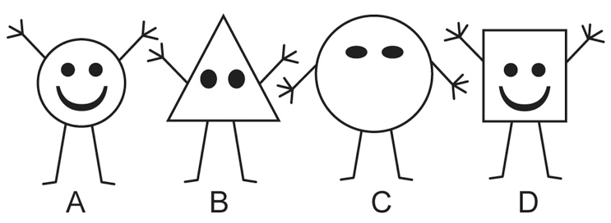

1 Round body Go to 3.
Not round body Go to 2.

2 Three fingers Gertie
Four fingers Iris

3 Mouth Fred
No mouth Harry

7) Which one is Iris?

a. A
b. B
c. C
d. D

8) Use the circular key below to classify an animal with 6 legs, 4 heads, 8 eyes and no mouth.

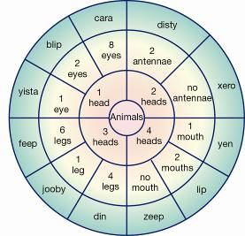

a. Feep
b. Xero
c. Cara
d. Zeep

9) Look at the four sea animals below:
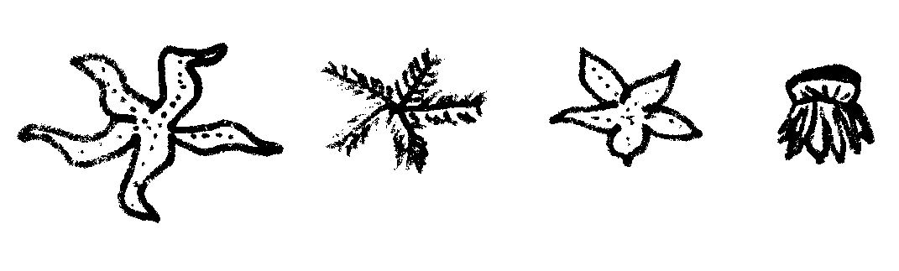
D
C
B
A
If three (3) of these animals were to be placed in one group and the remaining one in a separate group, which one would be in a group by itself?

- A
- B
- C
- D

10) Students created this key for their group.

1a Male Go to 2
b Female Go to 5
2a Straight hair Go to 3
b Curly hair Go to 4
3a Can roll tongue Mark
b Cannot roll tongue Yasu
4a Brown eyes Hans
b Grey eyes Jack
5a Straight hair Jane
b Curly hair Mai

Identify the description of Jack.
a) Straight-haired male with brown eyes that cannot role his tongue.
b) Curly-haired male with grey eyes.
c) Male that can roll his tongue and has grey eyes and curly hair.
d) Male with straight hair and brown eyes.



SEMESTER TWO 2019
Classification Science Test:
ANSWER BOOKLET

NAME:
FORM: DATE:

Multiple Choice Short Answer Total

/31

/10

/41

SECTION ONE: Multiple choice answers
Cross (X) through the correct answer.

1 | a | b | c | d
2 | a | b | c | d
3 | a | b | c | d
4 | a | b | c | d
5 | a | b | c | d
6 | a | b | c | d
7 | a | b | c | d
8 | a | b | c | d
9 | a | b | c | d
10 | a | b | c | d

ASSESSMENT KEY

I CAN STATEMENTS | QUESTIONS
MUST  Classifies organisms using observable similarities and differences and applying simple classification keys. | 1,2,3,4,5,10  11a,11bi,12,13,17
SHOULD  Classifies organisms using observable similarities and differences, constructing and applying classification keys. | 6,7,8,9  11bii,14, 18
COULD  Classifies unfamiliar organisms using observable similarities and differences, constructing and applying varied classification keys. | 15, 16

Part B: Short Answer Questions (31 marks)
Answer in the spaces provided.

- Biologists use factors or criteria to determine whether something is living or non-living.
a) Using MR N GREWW, write down the 8 criteria that an object must satisfy to be considered living. (4 marks)
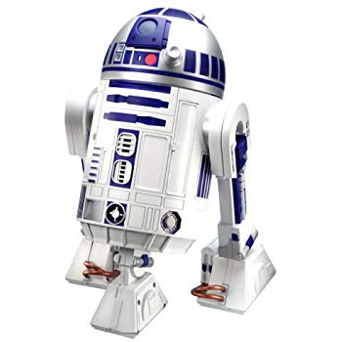
M____________________________________________________________________________
R_____________________________________________________________________________
N_____________________________________________________________________________
G_____________________________________________________________________________
R_____________________________________________________________________________
E_____________________________________________________________________________
W____________________________________________________________________________
W____________________________________________________________________________
b) This is a picture of a robot.
Sammy thinks robots are a living thing.
Bobby thinks the robots are a non-living thing.
i) Who is correct? Bobby or Sammy? (1 mark)
_________________________________________________________________________________________
ii) Using MR N GREW, explain your answer (2 marks)
________________________________________________________________________________________________
________________________________________________________________________________________________

12. To classify things, objects need to be compared to each other by looking at their similarities and differences. Below are two pictures. (2 marks)

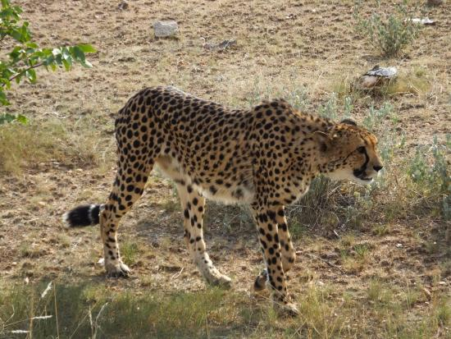
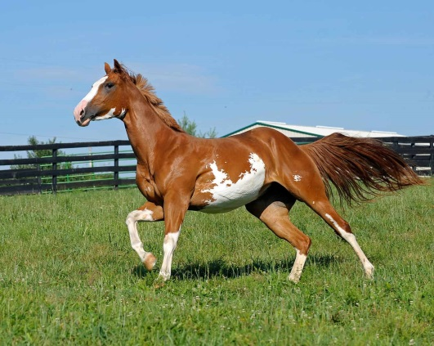

- Write down 2 similarities between the animals above
___________________________________________________________________________
___________________________________________________________________________
- Write down 2 differences between the animals above
___________________________________________________________________________
___________________________________________________________________________

13. We classify many things in everyday life, not just living things. (2 marks)
a) State two reasons of using classifications
____________________________________________________________________________________________________
____________________________________________________________________________________________________
____________________________________________________________________________________________________
b) Can you name two places in everyday life that classification is used
____________________________________________________________________________________________________
____________________________________________________________________________________________________
____________________________________________________________________________________________________

14. Use the key below to classify the animals pictured here. (4 marks)

KEY
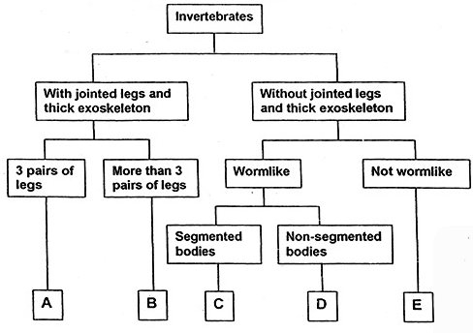

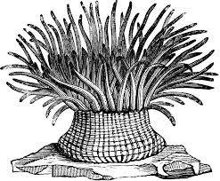
ANIMALS
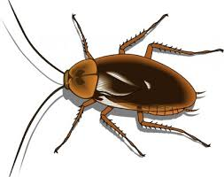
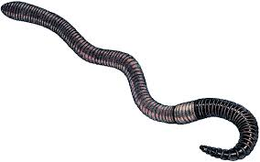
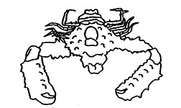

1 2 3 4

ANIMAL | GROUP (A,B,C,D or E)
1

2

3

4

15. Using the 3 creatures below, design a Dichotomous key (minimum of 3 steps)
to help identify them based on 2 or more specific characteristics. (3marks)

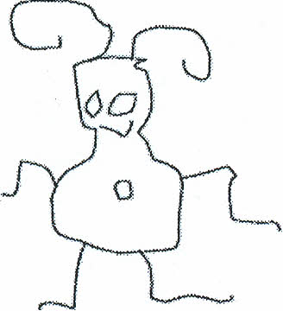

GLOP

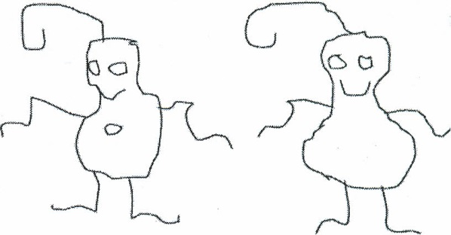
BIP
GLIP
16. Use the key to identify the name of each alien below. (5 marks)

Alien Dichotomous Key
1. A. Does the alien have feet?…………………………..Go to statement 2
B. Does the alien have no feet?……………………….Go to statement 7
2. A. Does the alien have socks?………………………..Go to statement 3
B. Does the alien have no socks?…………………….Go to statement 5
3. A. Does the alien have antennae?…………………….Go to statement 4
B. Does the alien have no antennae?…………………It is alien K
4. A. Does the alien have two eyes?…………………….It is alien R
B. Does the alien have less than two eyes?……………..It is alien M
5. A. Does the alien have toes?………………………….Go to statement 6
B. Does the alien have no toes?………………………It is alien T
6. A. Does the alien have long hair?…………………….It is alien Z
B. Does the alien have no long hair?………………….It is alien N
7. A. Does the alien have eyes on stalks?……………….Go to statement 8
B. Does the alien have eyes not on stalks?……………Go to statement 9
8. A. Does the alien have a nose?……………………….It is alien X
B. Does the alien have no nose?………………………It is alien Y
9. A. Does the alien have arms?…………………………It is alien V
B. Does the alien have no arms……………………….It is alien W

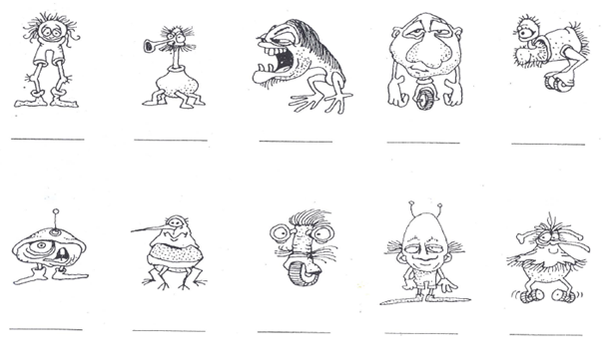
17. Classify the following living things
a) Dog (1.5 marks)
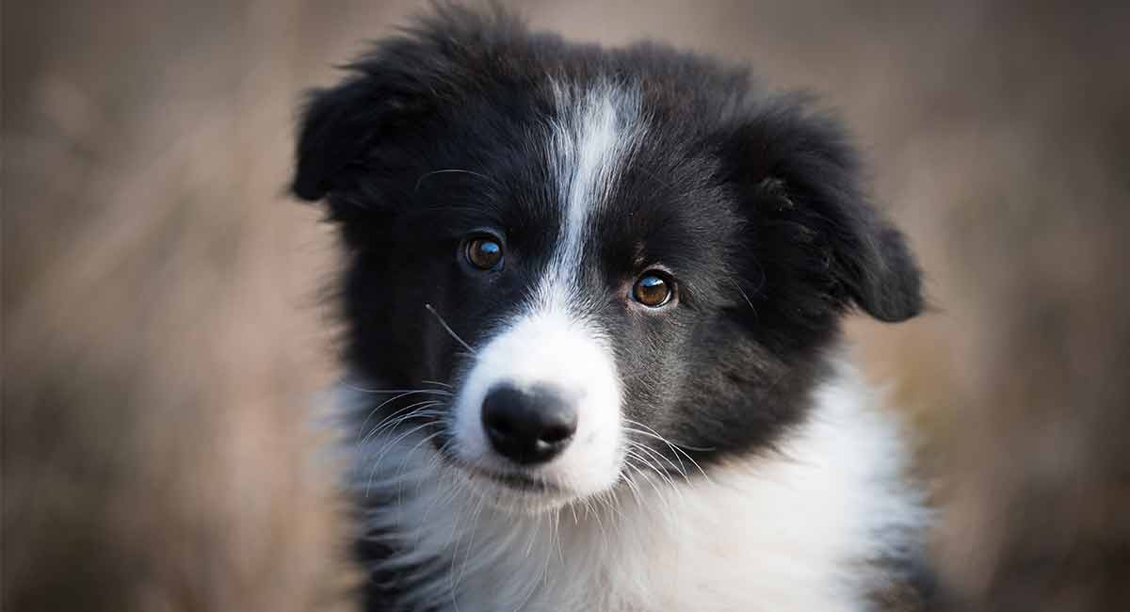
Kingdom
_____________________________
Phylum
_____________________________
Class
_____________________________

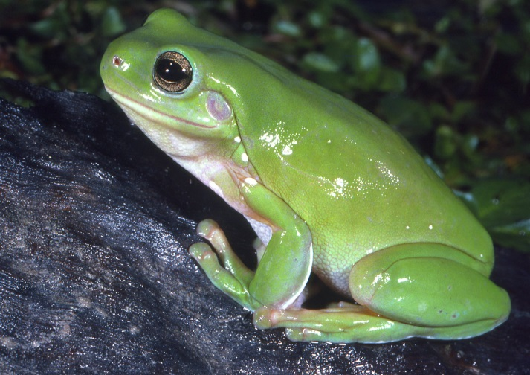
b) Frog (1.5 marks)
Kingdom
_____________________________
Phylum
_____________________________
Class
_____________________________

c) Turtle (1.5 marks)
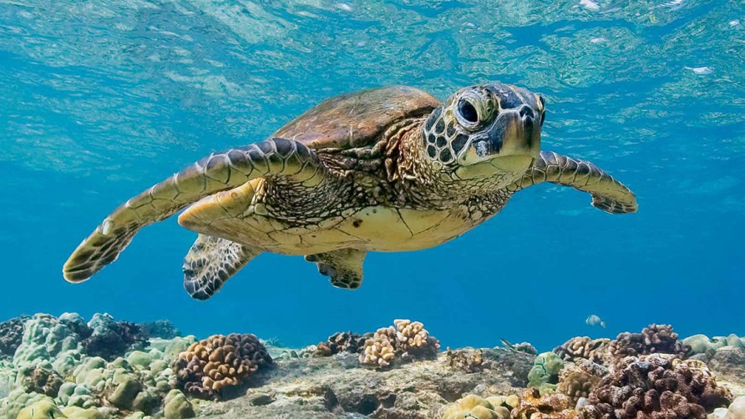
Kingdom
___________________________
Phylum
___________________________
Class
___________________________

d) Snail (1 mark)
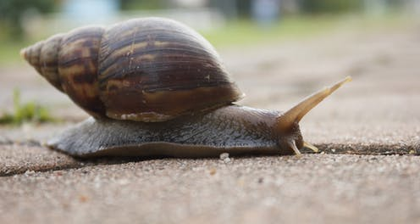
Kingdom
___________________________
Phylum
___________________________
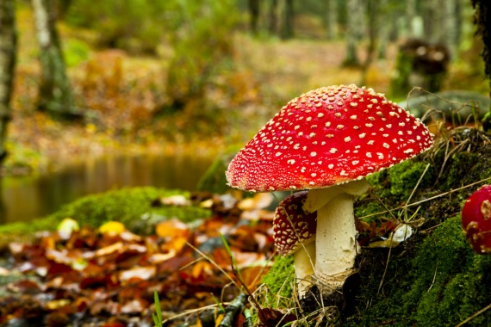
e) Toadstool (0.5 mark)
Kingdom
___________________________

f) Bacteria (0.5 marks)
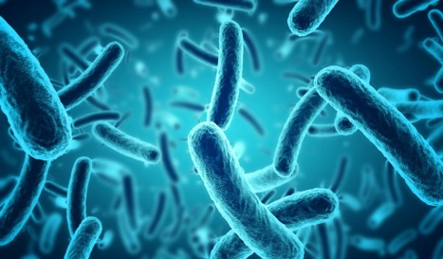

Kingdom
___________________________

18. A crocodile is a living thing. (1.5 marks)
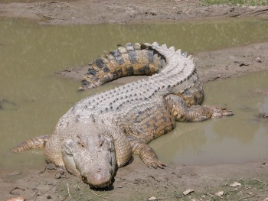
Can you describe the features of a crocodile why they are classified as below?

Kingdom: Animalia
Phylum: Chordata
Class: Reptile
______________________________________________________________________________
______________________________________________________________________________
______________________________________________________________________________

